Data Cloud
Overview of how data cloud works :
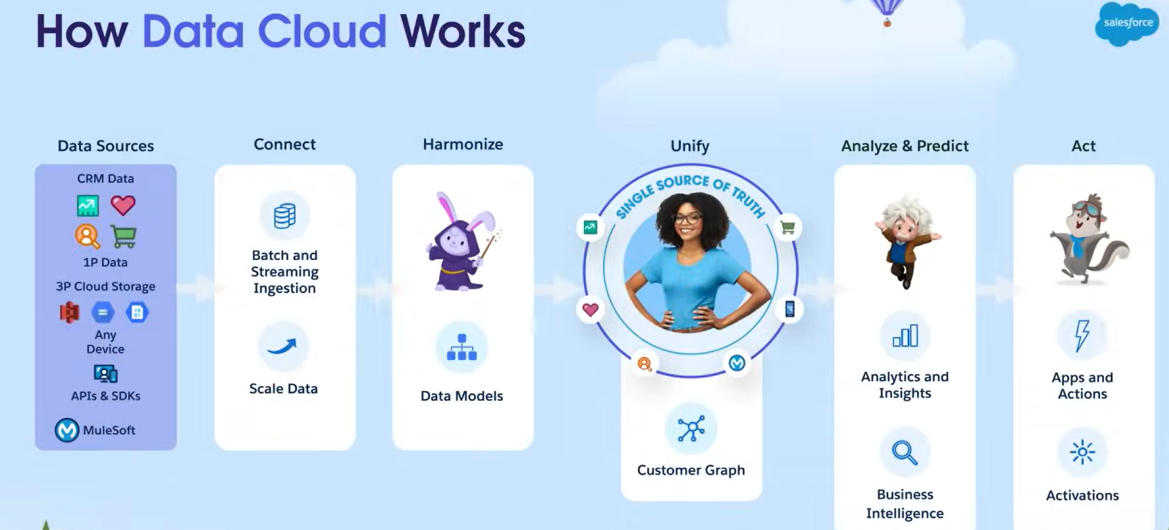
Bringing Data into Data Cloud
Bringing data into data cloud involves two phases
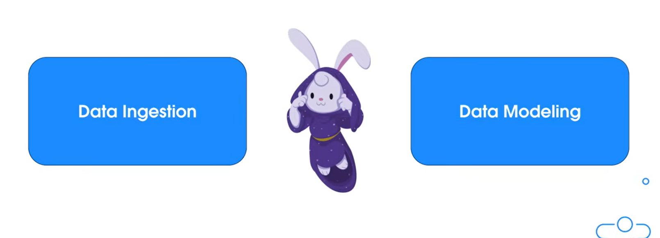
In the ingestion phase, data from data source is bought in as is (meaning their fields and data types are imported without any transformation)
Also known as Harmonization

To get a data into data source we must first establish a connection between the data source and data cloud we can do this with the help of connector. Salesforce offers many out of the box connectors.
Once a connector is setup, we create data streams to get different data set from the source system.
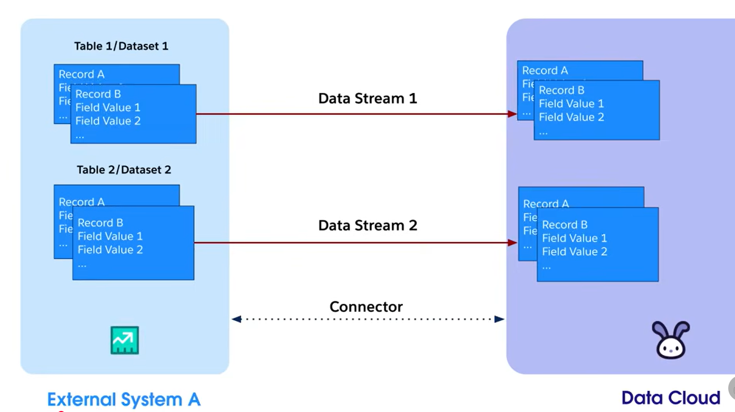
The data comes in through data stream is written to a data lake object (DLO), each stream has its own corresponding Data Lake Object (DLO).Once the data is written to the data lake object it is refreshed at regular intervals.
Data Stream: create stream to get data from external systems.
Data Model Object: creates different data models objects and creates relationships between them.
Identity Resolution: Once data is harmonized, we can use Identity Resolution tab to create matching and reconciliation rule to unify records.
Data explorer and Profile explorer: To view data that we have ingested and unified.
Calculate insights: Once data is harmonized, ingested data calculated creates metric of our data (write sql queries) these metrics can then be used to segment or drive actions.
Segment: Used to filter and group individual into segments.
Data Actions: where we fire events either based on ingested data or calculated insights. This event can be trigger automation downstream

